Blastrac 6-55DC

 | Blastrac's Deluxe Six Cartridge Auto Pulse Professional Vacuum is the preferred vacuum for the professional contractor requiring continuous operation and high performance. This is the Cadillac® of industrial dust collection.  This system features:  - Six cartridge system is set to pulse the filters every 15 seconds  - Work without performance loss  - An available electrical outlet on the dust collector  - Standard side removal dust cartridges to aid in the clean disposal of used dust  - An optional screw conveyor dust bin and bagging system  - An optional HEPA filtration unit for hazardous material handling  Application For use with large surface preparation jobs, including shotblasters, scarifying, and grinding.
  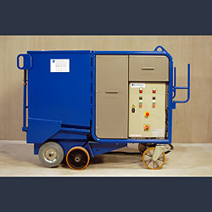
  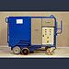 | 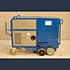 | 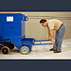

- Technical Specs

Dust Collectors Overview

- Accessories

Part Number: | 6-55DC
Voltage | 460V 3P
Amperage | 11A
*Maximum Air Flow | 1000 CFM
*Maximum Static Pressure | 21 Inches H20
*Dust Bin Capacity | 250 lbs
Vacuum Hose Diameter/Length | 5"/6" x 60 Feet
Dimensions (LxWxH) | 68" x 32" x 53"
Weight | 1433 lbs

